**The Linux File System**

● A file system controls how data is stored and retrieved.

● Each group of data is called a file and the structure and the logic rules used to manage files and their names are called file systems.

● A file system is a logical collection of files on a partition or disk.

● On a Linux system, everything is considered to be a file.

● On Linux file and directory names are case-sensitive.

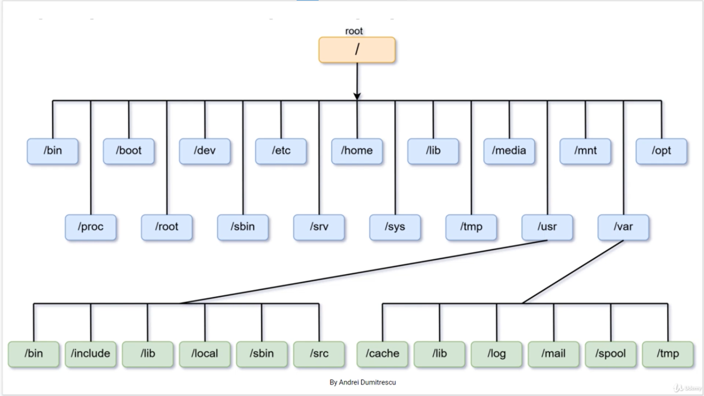

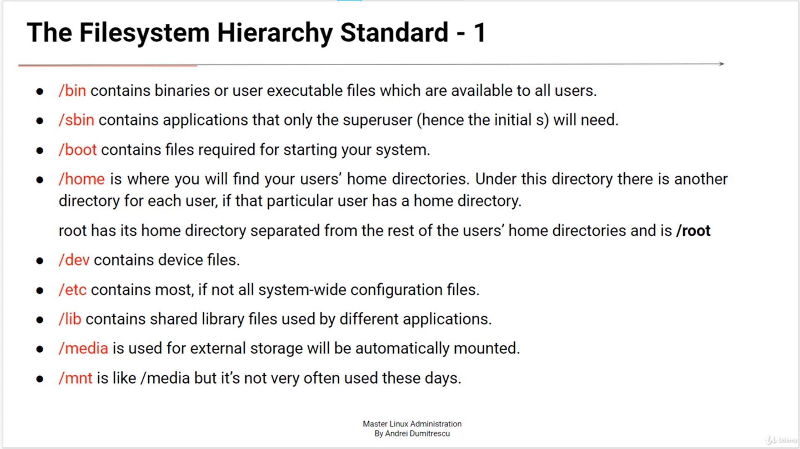

* Watch files inside a root directories



* Watch hidden files in root directory
* Use cd / t insert a root file



* We use df –h to see the file size

